Unity project

Alexandre Lepage 1732078

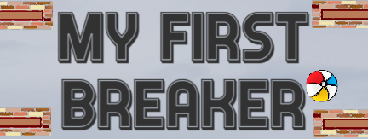

Game Info

# User stories:

1. Completed
2. Completed (plus):
   1. 10 different levels.
   2. As you finish last level you will continue to increase the ball speed, but you will be presented with a random level.
   3. Start with 4 beach balls, 3 stored and one already on the paddle.
3. Completed (plus):
   1. You have 3 credits to continue if you game over, if you select ‘Continue’ you will lose a credit continue the current level at its current states (brick destroyed will stay destroyed), score at zero and your ball speed is reset to initial value, get back all your life (4).
   2. Or you can select ‘Star Over’ you will start from level 1, score at zero, all life (4), all credits (3) and ball speed reset to initial value.
4. Completed (plus):
   1. You 5 shovel bullets you can shoot, and they will destroy any kind of blocks.
5. Completed (plus):
   1. Ball speed increase every level, not the Timescale (I did not like that). There’s a speed cap.
6. Completed (plus):
   1. Each destroyed brick gives points, the amount of points given can be changed by the level designer.
   2. 3 Different blocks
      1. 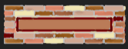 Normal, 1 hit
      2. 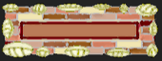 Hard, 2 hits, (1 hit from some power ups)
      3.  Indestructible, (some power ups will destroy it)
7. Completed (plus):
   1. Power UP and DOWN.
   2. There is a timer that shows the amount of time your power will stay active. Green for power up, red for power down.
   3. Fireball (UP)
      1. 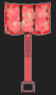 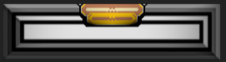 Shovel bullets, you get 5 ammo, change your paddle sprite, can destroy anything, persist through death and level change.
   4. Protection (UP)
      1. 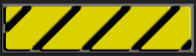 Floor protection, covers the pit under the paddle, persist through level change.
8. Multi-Ball (UP)
   * 1.  Extra ball spawn and stays up for 10 seconds, can destroy anything, does not persist through level change.
9. Mega Paddle (UP)
   * 1. 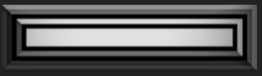 Grow Paddle, persist through death and level change.
10. Mega Ball (UP)
    * 1. 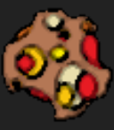 You ball is huge and on fire it goes through everything, destroys all, does not persist through level change or death.
11. Glue (UP)
    * 1.  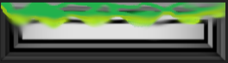 Glue paddle, the ball stick to your paddle and you can a laser beam to aim in the direction you want to launch your ball, persist through death and level change.
12. Mini Paddle (DOWN)
    * 1.  Shrink the paddle, persist through death and level change.
13. Shrink Ball (DOWN)
    * 1.  Mini ball that cannot destroy anything, and will bounce between bricks, you must survive, does not persist through level change or death.
14. Speed up (stacks) (DOWN)
    * 1. Increase the speed of the ball, persist through level change and death.
15. Speed down (stacks) (UP)
    * 1. Lower the speed of the ball.
16. Life Up (BONUS)
    * 1. Give player and extra life if he had lost one, maximum of 3 extra life.
17. Completed (plus)
    1. All new sprites
    2. Options can adjust master volume, music, sound FX, Quality and sensitivity for control using keyboard or gamepad.
    3. Created an editor BSG Menu, Builder Scene Generator, for easier scene manipulation in the build setting.
18. Completed (plus)
    1. There are 2 songs one in the Welcome Scene and one in the Play Scene
    2. The play scene one goes muffle when the play goes to the menu.
    3. There is loads of special effects for each powerups
    4. The sound is 3D.
19. Completed (plus)
    1. You can use mouse, just click anywhere and the paddle will line up on the X axis, Default right mouse to fire.
    2. You can use “aswd” “arrow keys” with space bar to shoot.
    3. Gamepad  
       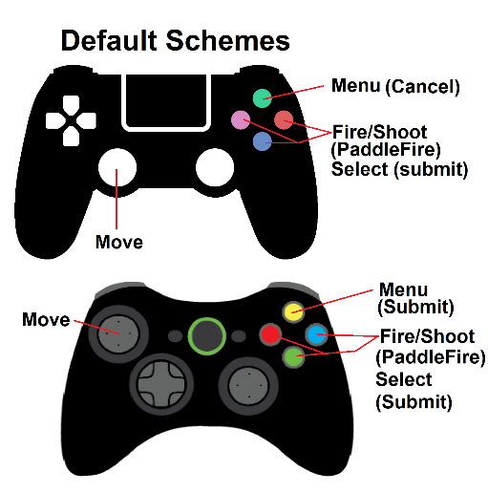
    4. Smartphone  
       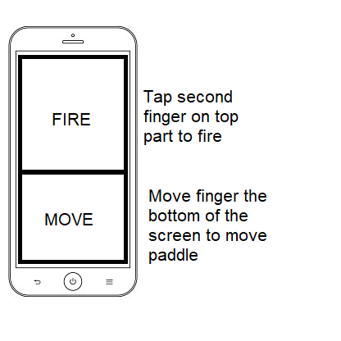
20. Completed (plus)
    1. The power ups are the collectables they give you extra points when you catch them even if you already have a power active you can catch others for bonus.
    2. The most valuable ones are hidden inside indestructible block.
21. Completed (plus)
    1. Leaderboard: Holds the first 10 rank with initial, if you ranked from 11 to 100 you will see it after you die, but over rank 100 it will just say “You ranked over #100”
    2. When entering your initials (3 max), there is buttons for each letters and numbers for easy access and touch screen functionality
22. Completed (plus)
    1. The game automatically adjusts for the screen type, portrait mode, wide screen or square.
    2. On smartphone is force portrait mode.
23. Completed (plus)
    1. Made the whole game beach themed.
    2. Loads of particle effects
    3. Splash when the ball or powers falls in the water
    4. Moving waves
    5. There is a day and night cycles set to 2 minutes (day to night).
    6. Level change text animation
    7. Power text animation

# External resources/references

Resources are part of the assets: ‘Sound, Music, Fonts, Images’ there is a txt file name the same as the resource used that contains all the references. All the sprites are made by me, the ocean image is my own photo except the star night sky has its txt file with references.

# Extra

I have fixed the selection bug where when you click outside a selectable it unselects it and you can’t move with the keyboard again you have to hover with your mouse.